1.Create user with name Techie and provide sudo access to user.

Step 1: use **useradd techie** command to create a user

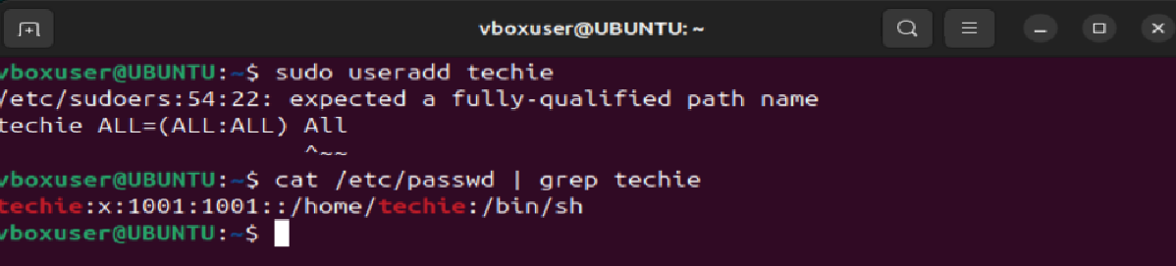

Step 2: switch to root user by using **sudo su -** command and search for a file named sudoers by using **find / -name sudoers** command

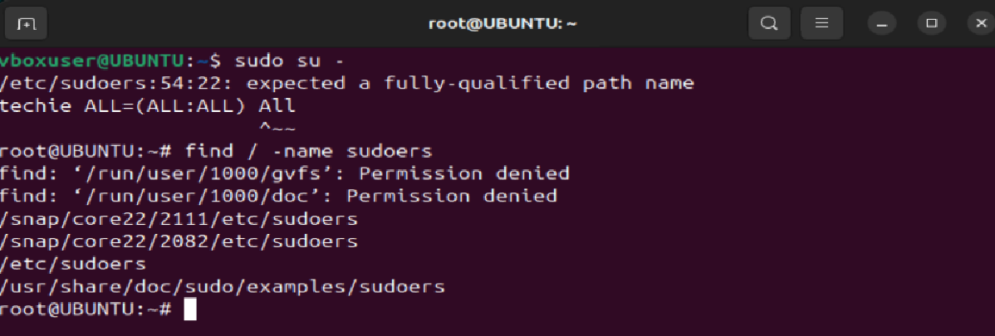

Step 3: Type **techie ALL=(ALL:ALL) ALL** below **# Allow members of group sudo to execute any command**

****2.  Navigate to the home directory.

Step 1: use command **cd** tonavigate to home directory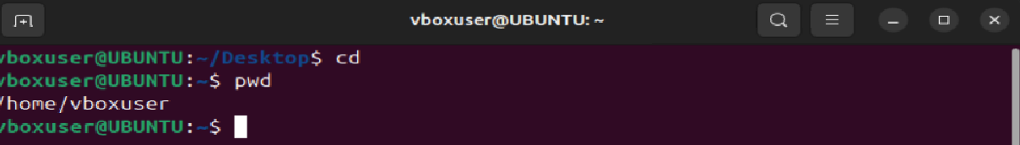]

1. Create a new directory.

Step 1: use command **mkdir techie** to create a directory

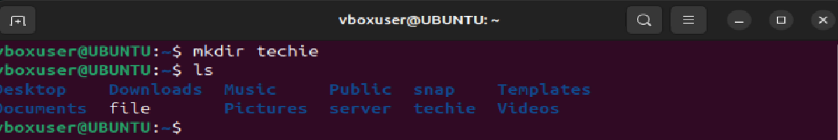

4.  List the contents of a directory.

Step 1: use command **ls** to list the content of a directory

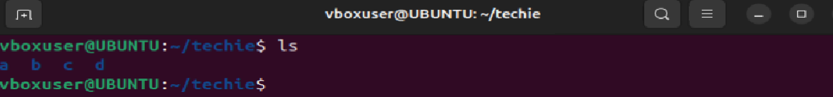

5. Change the current directory

Step 1: Use command **cd a** to change to a directory

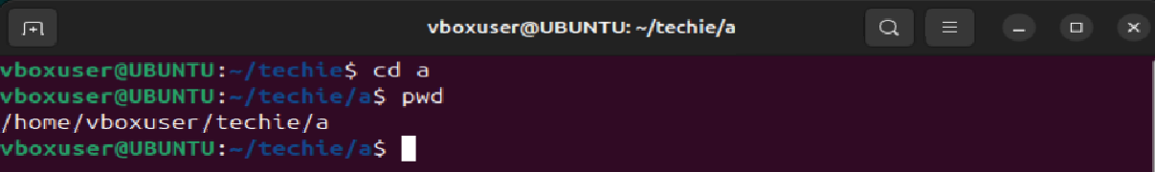

6. Create a new empty file

Step 1: Use command **touch file** to create a new empty file

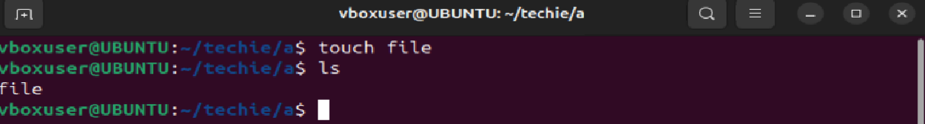

7. View the content of a file

Step 1: Use command **cat file** to view the content of a file

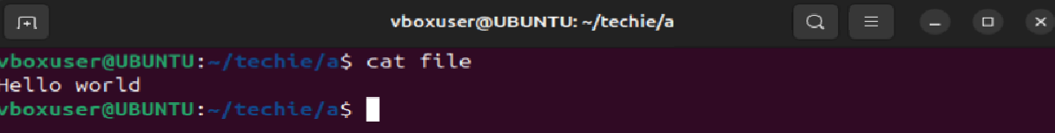

8. Copy a file to another location

Step 1: Use **cp /source_path /destination_path** commandto copy a file to another location.

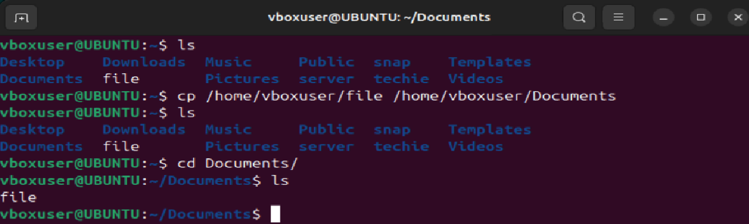

9. Move a file to another location

Step 1: Use **mv /source_path /destination_path** command to copy a file to another location.

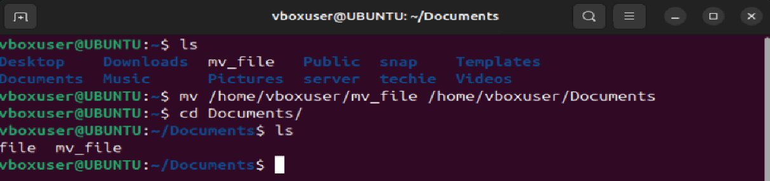

10. Rename a file

Step 1: Use **mv file cp_file** commandto rename a file

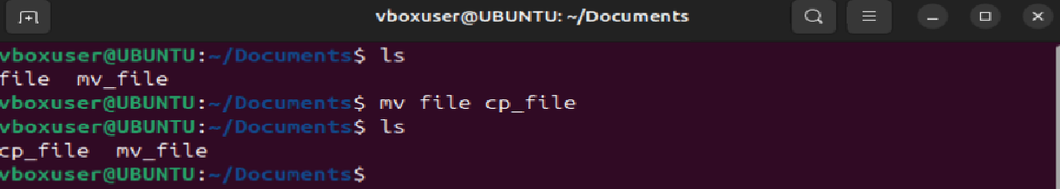

11. Delete a file

Step 1: Use **rm filename** command to delete a file

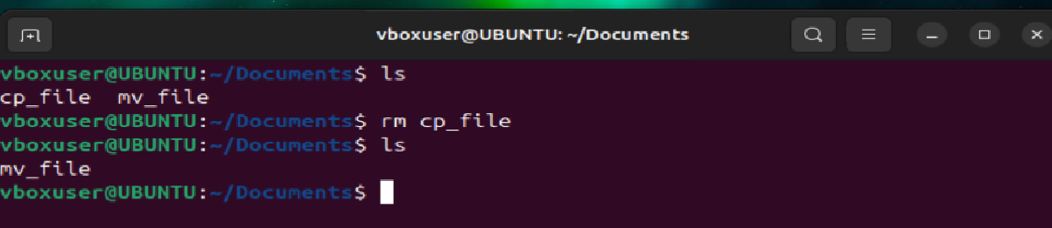

12. Grant or revoke permissions on a file or directory.

Step 1: Use **chmod 147 filename** command to grant or revoke permission for a file or directory

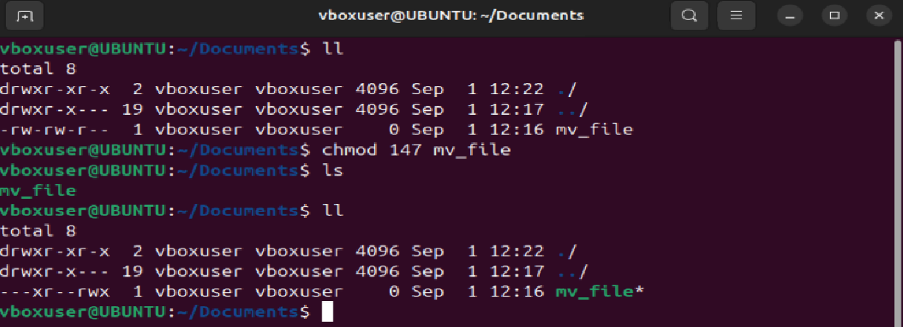

13. View the current date and time

Step 1: Use **date** commandto view current date and time

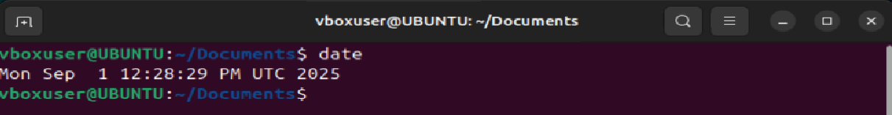

14. Check the system uptime

Step 1: Use **uptime** commandto check the system uptime

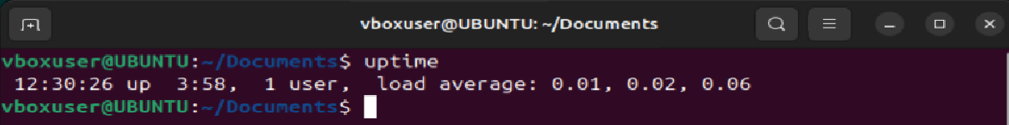

15. View the running process

Step 1: Use **ps -ef** command to view the running process

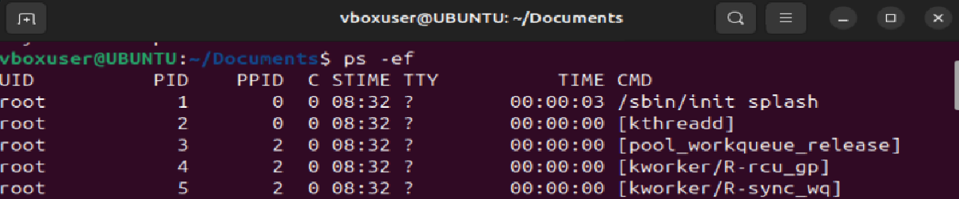

16. Kill a running process

Step 1: Use **kill -9 pid** command to kill the running process

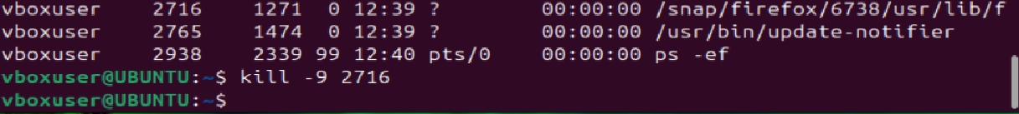

17.  Install a package using the package manager (e.g., apt or yum).

Step 1: Use **sudo apt install package_name** command to install a package

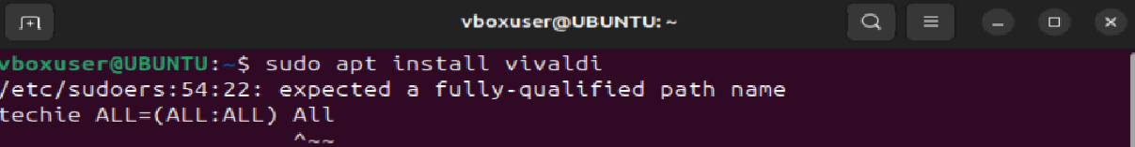

18. Update the system packages.

Step 1: Use **sudo apt update**  command



19. Create a symbolic link.

Step 1: Use **ln -s source_path destination_path** command to create a symbolic link.

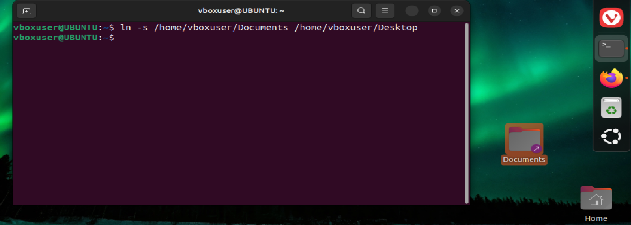

20. Search for files using the find command.

Step 1: Use **find / -name file_name**  command to search for a file

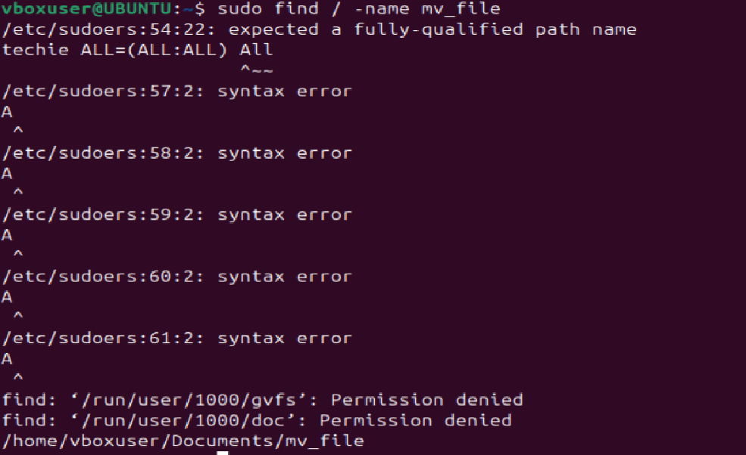\

21. Compress and decompress files using tar.

Step 1: Use **tar cvf filename.tar source_path** command to compress and **tar xvf filename.tar** command to extract

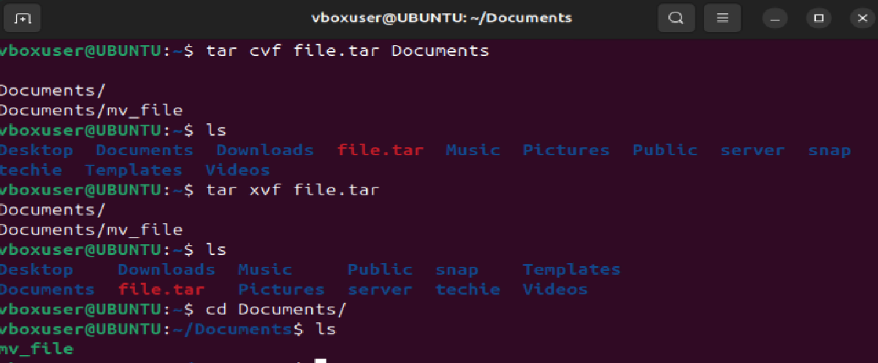

22. Monitor system resources with top or htop.

Step 1: Use **top** and **htop** commandto monitor system resource

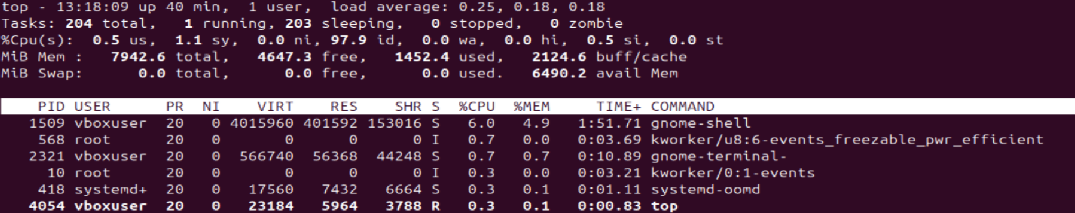

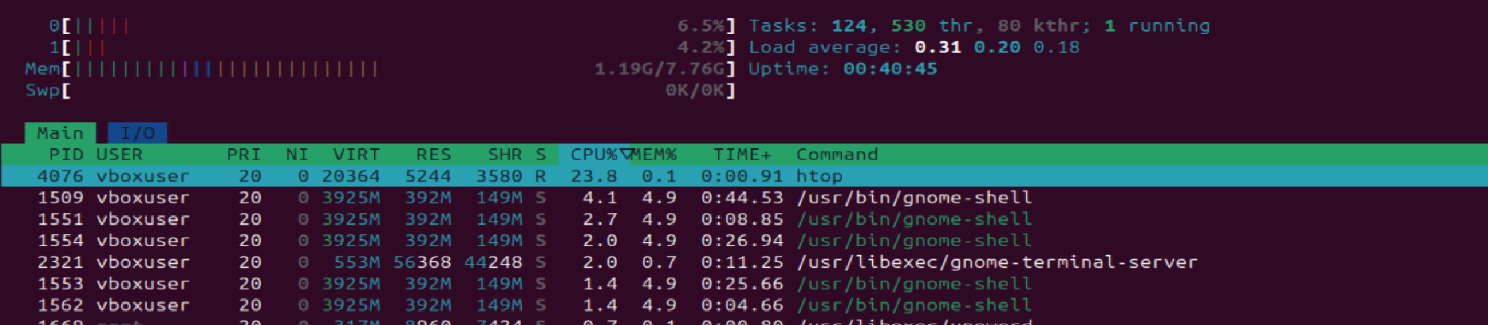

23. Create and manage user groups.

Step 1: Use **sudo groupadd group_name** command to create a groupand **sudo usermod -aG groupname username** to add a user.

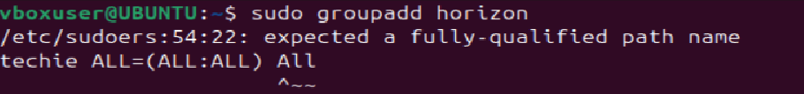

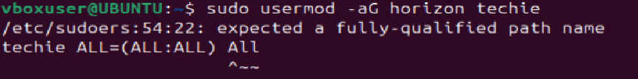

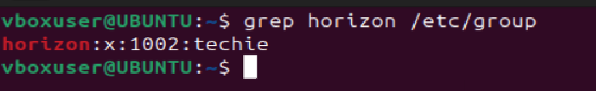

24. Set up SSH password less authentication.

Step 1: Use **ssh -i securitykey.pem ec2-user@public_ip** to

Set up SSH password less authentication.

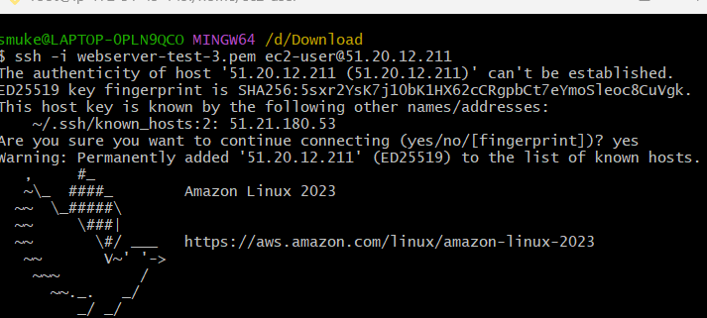

25. Monitor log filesusing tail or grep

Step 1: use **tail -f /var/log/syslog** to monitor log files

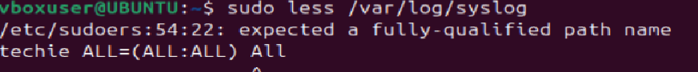

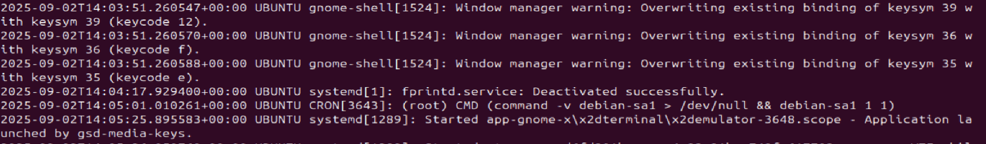

26. Set up a web server (e.g., Apache or Nginx).

Step 1: Use **sudo apt install nginx** to set up nginx web browser.

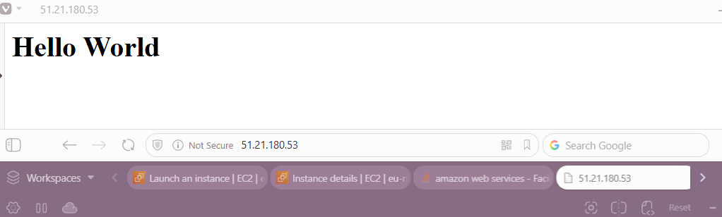

27. Configure and secure a MySQL Database.

Step 1: Use **sudo apt install mysql-server** to install mysql



Step 2: Use **sudo mysql_secure_installation** to essential security configurations



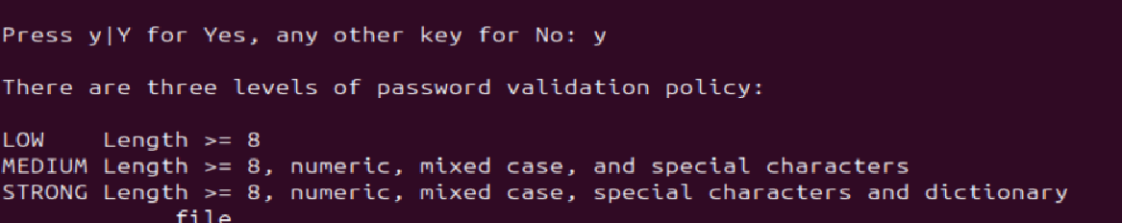

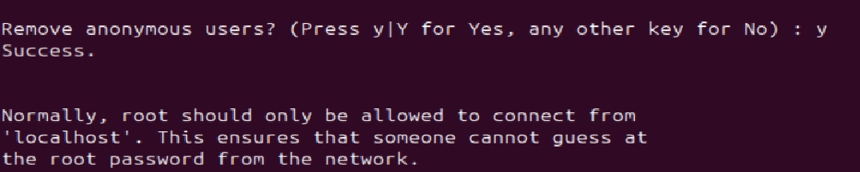

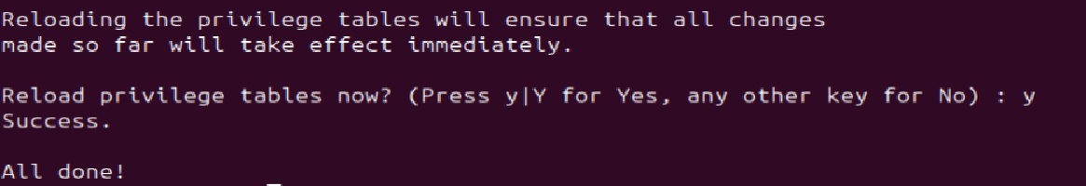

28. Setup Application server

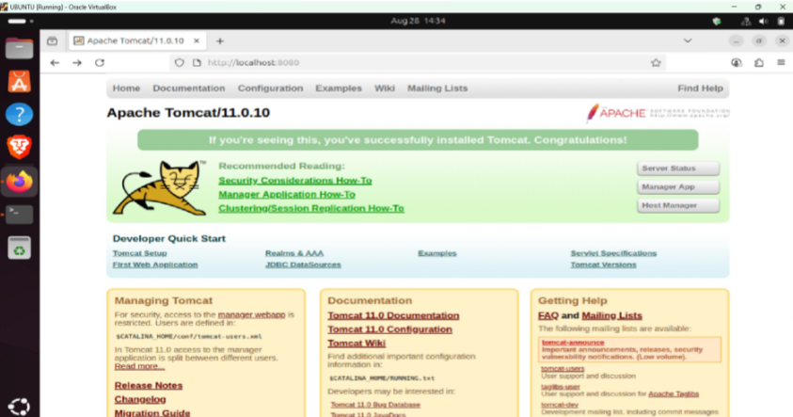

29. create a service file for Apache Tomcat.(Should execute by using systemtctl command)

Step 1: Use **sudo nano /etc/systemed/system/tomcat.service** to create a service file and add data to the file



Step 2: Use **sudo systemctl daemon-reload** to reload



Step 3: Use **sudo systemctl enable tomcat.service** to enable



Step 4: Use **sudo systemctl start tomcat.service** to start



30.  Print specific columns from a delimited file.

Step 1: Use **awk '{print $m, $n}' file.txt** command to print specific column

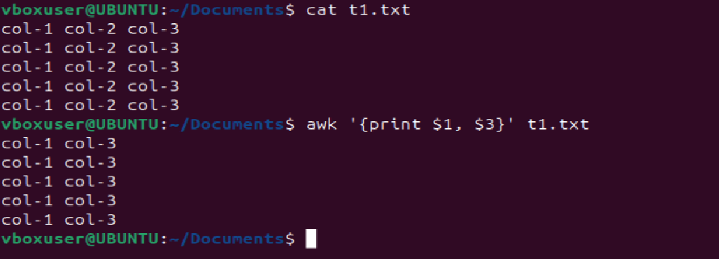

31. Filter and print lines based on a specific pattern or condition.

Step 1: Use **grep "error" file.txt** command to print

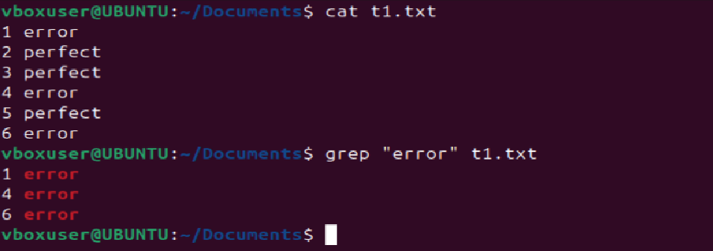

32. Calculate and print the average, sum, or other statistics of a column.

Step 1: use **awk '{sum += $3} END {print "Sum =", sum}' file.txt** command to calculate sum and use **awk '{sum += $3; count++} END {print "Average =", sum/count}' file.txt** command for average.

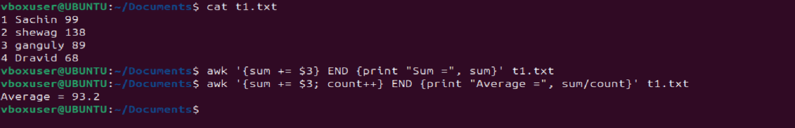

33. Perform string manipulation, such as extracting substrings or changing case.

Step 1: Use **cut -c1-9 file.txt** to extract substring

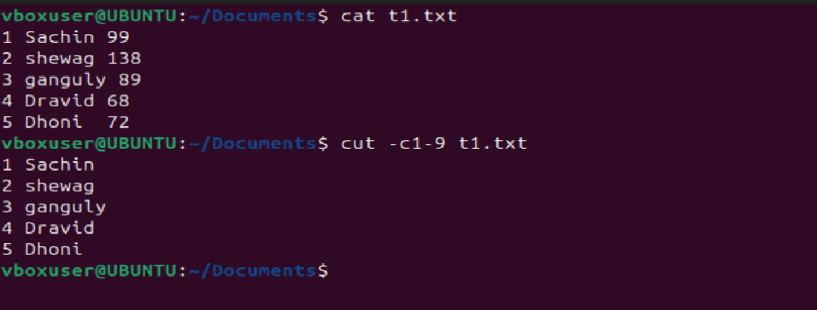

34. Count the occurrences of a specific pattern in a file.

Step 1: Use **grep -c “pattern” file.txt** to count occurance

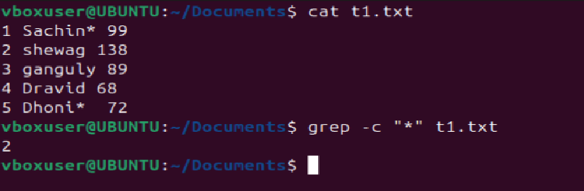

35. Sort lines based on a specific field or column.

Step 1: **Use sort -k3,3n file.txt**  to sort based on column.

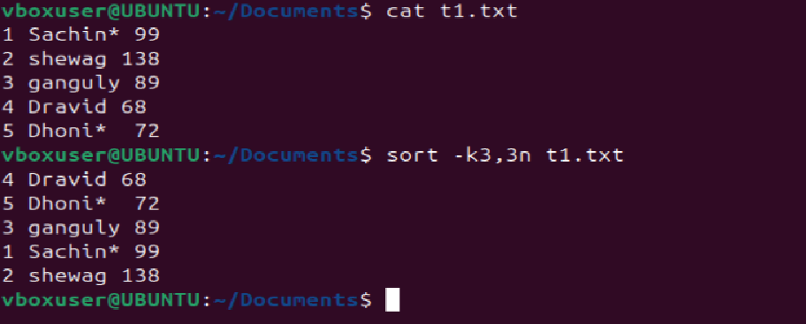

36. Merge multiple files based on a common field or column.

Step 1: Use  **join file1 file2 > merged** command to merge multiple files

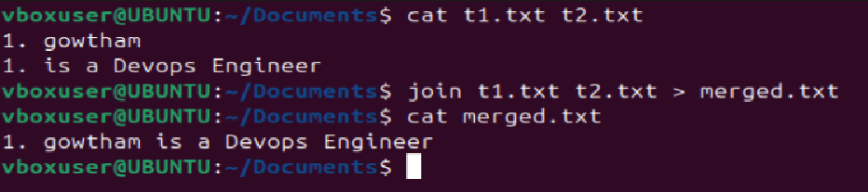

37. Substitute text in a file using search and replace.

Step 1: Use **sed’s/old/new/g’ file_name**  to substitute text in a file

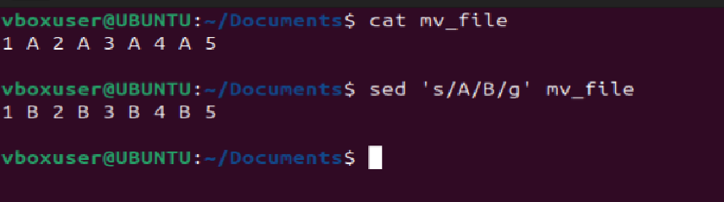

38. Delete specific lines based on a pattern or line number.

Step 1: Use **sed 'm,nd' filename** command to delete specific lines

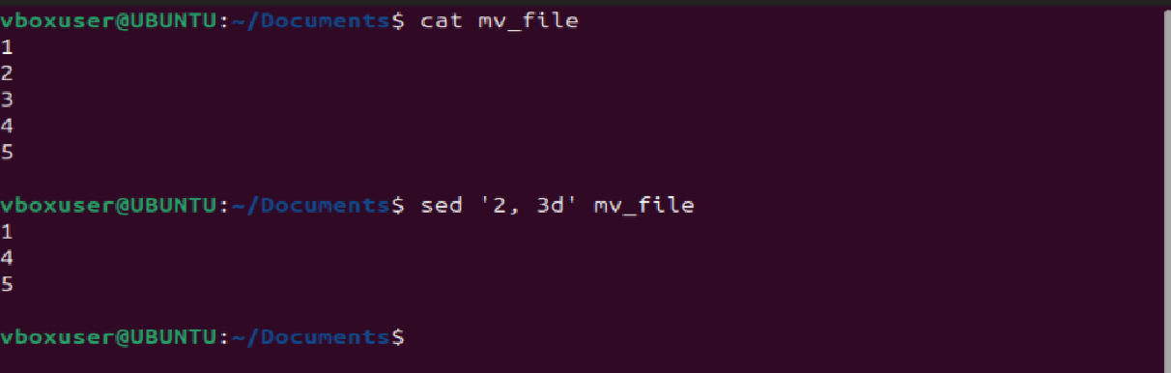

39. Append or insert text before or after a specific pattern or line.

Step 1: use **sed '3i\inserted before line 3 ' filename** command to print before a specific line.

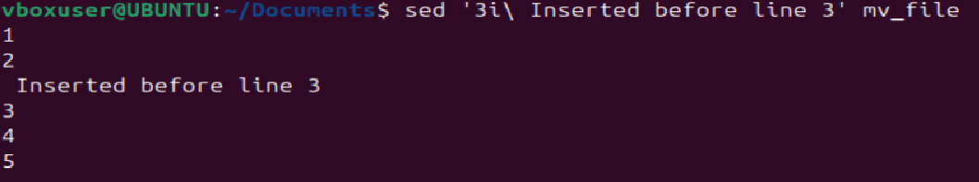

40. Print only specific lines from a file.

Step 1: use **sed -n 'N p' filename** command to print only spefic lines from a file.

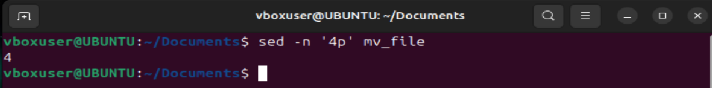

41. Copy file from linux to windows machine

Step 1: Use **scp -i /path/to/your/keypair.pem /path/to/local/file.txt Administrator@<Public_IP>:/path/on/windows/server/** to copy from linux to windows machine

42. 5 use cases for AWK and 5 use cases for sed

**awk**

a. awk '{print}' filename.txt – to print whole file

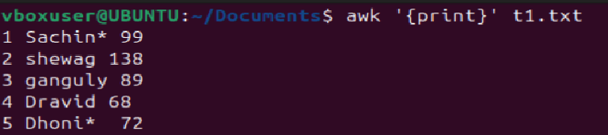

b. awk '{print $1, $3}' filename.txt – to print specific column

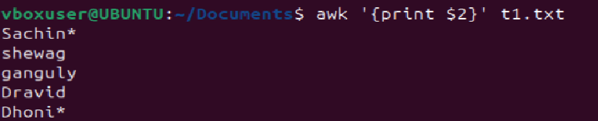

c.awk '/pattern/ {print}' filename.txt – to print specific pattern



d. awk '{sum += $2} END {print "Total sum:", sum}' data.txt

to do arithmetic operations



e. awk '$4 > 50 {print $1, $2, $3}' file.txt – for condition

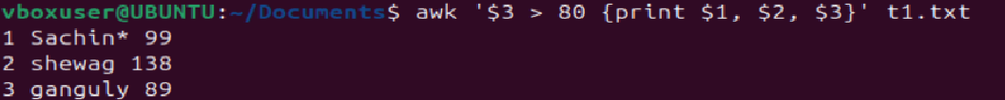

**Sed**

**a. sed ‘nd’ file,txt**  to delete a specific line

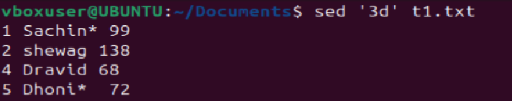

**b. sed ‘m, nd’ file.txt** to delete a range of lines

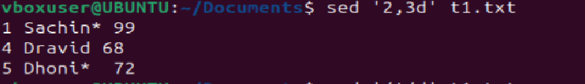

**c. sed ‘/pattern/d’ file.txt**  to delete lines folling pattern

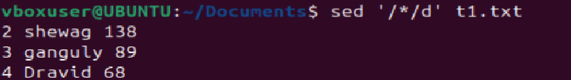

**d. sed -n ‘3p’ file.txt** to print a specific line



**e. sed ‘ni\ line’ file.txt**  to add data before a line

